** A computer is best for this.
Step 1
- Please visit: https://nohaparent.respectgroupinc.com/
- Enter your Username and Password (username is typically your email address).

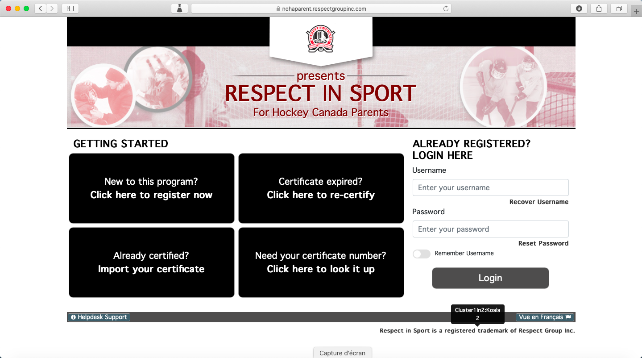

Step 2
- Click on profile (top left hand corner of page).
- Click on Child management.
- To the right of the page is your child’s HCR #.

